The Chinese University of Hong Kong

Department of Computer Science and Engineering

CENG2030 Fundamentals of Embedded System Design

Lab 4: Basic Circuit Analysis

Answer Sheet

Student Name: SID:

1. **KVL and KCL [54%]**
   1. Create and upload the TSC circuit file. [10%]
   2. Voltage measurement

Vcc: ____5V_______ [4%]

V1: ___3.33V____ [4%]

V2: ____1.67V____ [4%]

V3: ____1.67V____ [4%]

Equation: Vcc = ___V1+(V2+V3)/2____________ [4%]

* 1. Current measurement

I0: __-3.33mA____ [4%]

I1: __3.33mA___ [4%]

I2: __-1.67mA__ [4%]

I3: __1.67mA___ [4%]

Equation: I0 = ___-I1______________ [4%]

Equation: I1 = __-I2+I3______________ [4%]

1. **Passive Low Pass Filter [46%]**
   1. Create and upload your circuit in TSC file. [10%]
   2. Frequency Response
      1. Collected Data [12%]

|  |  |  |  |  |  |  |  |  |  |  |  |  |
| --- | --- | --- | --- | --- | --- | --- | --- | --- | --- | --- | --- | --- |
| Frequency of Vin  (Hz) | 50 | 100 | 200 | 500 | 1k | 2k | 5k | 10k | 20k | 50k | 100k | 200k |
| V**p** of Vout  (V) | 5.99 | 5.95 | 5.82 | 5.08 | 3.74 | 2.22 | 943.06 | 475.96m | 238.54m | 95.48m | 47.74m | 23.87m |

1. Cut-off Frequency

fc: $fc=\frac{1}{2πCR}$ = ___795.77Hz___ [4%]

Vout at fc: ____4.24V____ [4%]

1. Graph Plotting [16%]

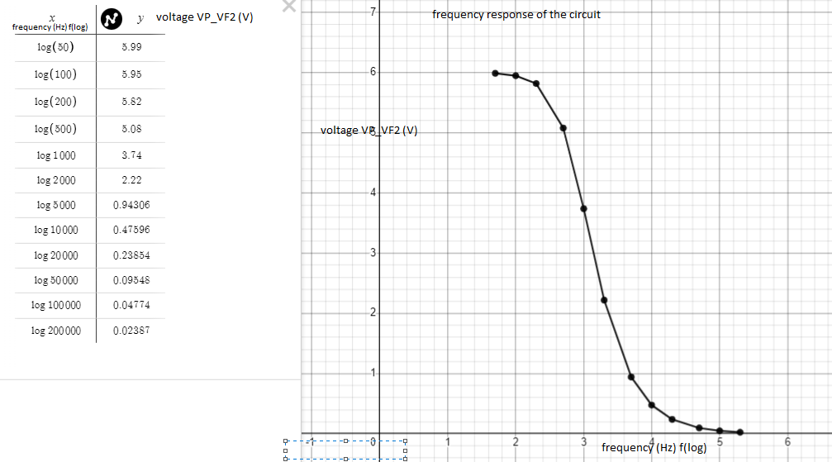

THE END